* If you get the following error, you may be using an older version of Jupyter.

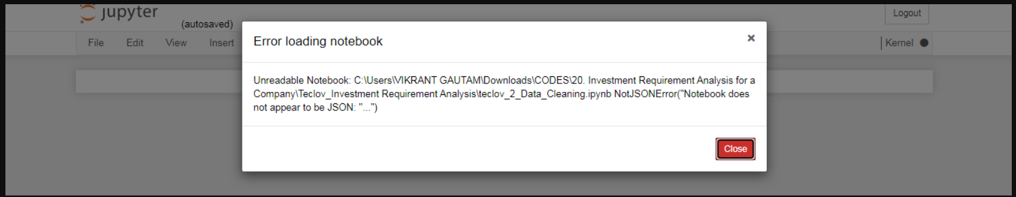

* Please refer to this link for a solution: **https://stackoverflow.com/questions/32103772/unreadable-notebook-notjsonerrornotebook-does-not-appear-to-be-json-u-n**
* You can also try creating the Jupyter here once: [**https://jupyter.org/try**](https://jupyter.org/try)

If it still does not work, please let me know what versions of Jupyter and Python you are running.